**Spy Satellite**

From Wikipedia, the free encyclopedia

[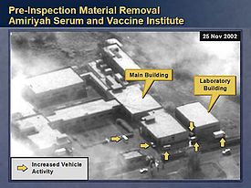](http://en.wikipedia.org/wiki/File:Iraq-030205-powell-un-slide-15.jpg)

Serum and Vaccine Institute in Al-A'amiriya, Iraq, as imaged by a US reconnaissance satellite in November 2002.

[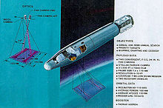](http://en.wikipedia.org/wiki/File:Kh-4b_corona.jpg)

KH-4B Corona satellite

[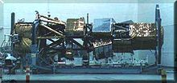](http://en.wikipedia.org/wiki/File:Lacrosse_sat.jpg)

U.S. Lacrosse radar spy satellite under construction

[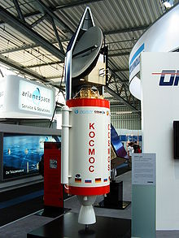](http://en.wikipedia.org/wiki/File:SAR-Lupe.jpg)

A model of a German SAR-Lupe reconnaissance satellite inside a Cosmos-3M rocket.

[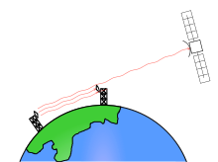](http://en.wikipedia.org/wiki/File:Rhyolite_sat.svg)

Microwave interception (Rhyolite)

A **spy satellite** (officially referred to as a **reconnaissance satellite**) is an Earth observation satellite or communications satellite deployed for military or intelligence applications. These are essentially space telescopes that are pointed toward the Earth instead of toward the stars. The first generation type (i.e. Corona and Zenit) took photographs, then ejected canisters of photographic film, which would descend to earth.

Corona capsules were retrieved in mid-air as they floated down on parachutes. Later spacecraft had digital imaging systems and uploaded the images via encrypted radio links.

In the United States, most information available is on programs that existed up to 1972. Some information about programs prior to that time is still classified, and a small trickle of information is available on subsequent missions.

A few up-to-date reconnaissance satellite images have been declassified on occasion, or leaked, as in the case of KH-11 photographs which were sent to *Jane's Defence Weekly* in 1985.

**Origins**

On March 16, 1955, the United States Air Force officially ordered the development of an advanced reconnaissance satellite to provide continuous surveillance of 'preselected areas of the earth' in order 'to determine the status of a potential enemy’s war-making capability'. In October 1957, the Soviet Union launched Sputnik 1. It was the first man-made object put in Earth's orbit.

**Missions**

Examples of reconnaissance satellite missions:

* High resolution photography (IMINT)
* Measurement and Signature Intelligence (MASINT)
* Communications eavesdropping (SIGINT)
* Covert communications
* Monitoring of nuclear test ban compliance (see National Technical Means)
* Detection of missile launches

**Benefits**

During the 1950s a Soviet hoax had led to American fears of a bomber gap. After the United States gained satellite photography its intelligence agencies were able to, for example, in 1968 state with certainty that "No new ICBM complexes have been established in the USSR during the past year." President Lyndon B. Johnson told a gathering in 1967:

I wouldn't want to be quoted on this ... We've spent $35 or $40 billion on the space program. And if nothing else had come out of it except the knowledge that we gained from space photography, it would be worth ten times what the whole program has cost. Because tonight we know how many missiles the enemy has and, it turned out, our guesses were way off. We were doing things we didn't need to do. We were building things we didn't need to build. We were harboring fears we didn't need to harbor.